VIETNAM NATIONAL UNIVERSITY OF HOCHIMINH CITY

THE INTERNATIONAL UNIVERSITY

SCHOOL OF COMPUTER SCIENCE AND ENGINEERING



**PROJECT REPORT**

**E-commerce Website**

**TechStore**

By

Tran Hai Nam

Advicers:

Dr. Huynh Kha Tu

A thesis submitted to the School of Computer Science and Engineering

in partial fulfillment of the requirements for the degree of   
Bachelor of Information Technology/Computer Science/Computer Engineering

Ho Chi Minh City, Vietnam  
Year

**E-commerce Website**

**TechStore**

APPROVED BY: ________________________________ ,   
Tran Hai Nam – ITITIU19161

________________________________

THESIS COMMITTEE   
(Whichever applies)

# TABLE OF CONTENTS

TABLE OF CONTENTS 3

CHAPTER 1 3

INTRODUCTION 3

1.1. Introduction 3

1.2. Arms projects 3

CHAPTER 2 4

PLAN OF PROJECT 4

2.1. Student: 4

2.2. Teacher: 4

CHAPTER 3 4

GOAL ATTAINMENT 4

3.1. Student 4

3.2. Teacher 4

CHAPTER 4 4

FUTURE WORK 4

REFERENCES 4

APPENDIX 5

# CHAPTER 1

# INTRODUCTION

## Introduction

Project Internship IU was started because it recognized the needs and difficulties of the students in applying for the internship. The main difficulties revolve around the lack of clarity in understanding the internship sequence, especially in finding internship companies. The teacher guides and evaluates the practice content.

## Arms projects

The main goal of the project is to use technologies to create a web app that can support and make it easier for students to find a credit-up company to practice and track the process. own practice. Teachers are also more proactive in supporting students during the internship and quickly making a report for the school fee about the student's internship process.

# CHAPTER 2

# PLAN OF PROJECT

An internship project is a project to support the internship process in school. The project will have two main objects, which are the Teacher and the Student. So that is why the project will be built with two interfaces for 2 objects. Extra object is admin how manage website.

## Student requires:

User Authendication: Create a Login page. The student accesses the web use their student account and web app will redirect to student page.

Jobs list: The website should have a list of internships available for students (This will show in center home page), which should include the job title, company name, job description, location, and application deadline.

Figure : Example for jobs list

Figure 1 is an example of UI to display jobs for student’s website will have.

Company profiles: The website should allow companies to create a profile, which should include information about the company, its mission, vision, and values, and a list of current jobs they hire.

Communication tools: The website should have a built-in communication system that allows students and companies to communicate with each other regarding the application process. The students can also communicate with their teacher and instructor on this website.

Writing Curriculum Vitae (CV): The website supports creating CV forms for students to fill out and save in the system. Students also upload their personal CV on page CV.

Application process: The website should allow students to apply for internships by submitting their CVs and cover letters. The application should also include a form that captures the student's personal details such as name, email address, phone number, and educational background.

Notifications: The website can send notifications to students when a new internship is posted that matches their preferences and notify companies when a student applies for one of their internships. The website also sends notifications to teachers when students change their status of having received or completed an internship.

Chat: The website provides a chat method for students can communicate with their teacher

Report from: The website provides a list or form of internship report for students. Students can submit their report on this web app.

## Teacher requires:

User authentication: The teachers will use accounts which are provided by the school to login to this web app.

Manger Student: The website supports Teachers to see all the students they manage. Teachers can visit the student page to view their CVs and make suggestions for students' CVs.

Grading: During the time before the internship period ends, the website will send a notice to students for students to submit internship reports and teachers based on that to give student grades. Websites have a page for Teacher view again and edit after that they can export it to submit for school.

Notifications: The website will send notifications to Teacher when the students apply a job or register their instructor.

Chat: The website will provide chat box for teachers can communicate with students.

Report form: website also provides list of report form for teachers make report.

## Design System:

### Use case diagram:

Based on some requirements and analysis of the website. The InternshipIU web app will have 2 main actors are students, teachers and extra actor is admin.

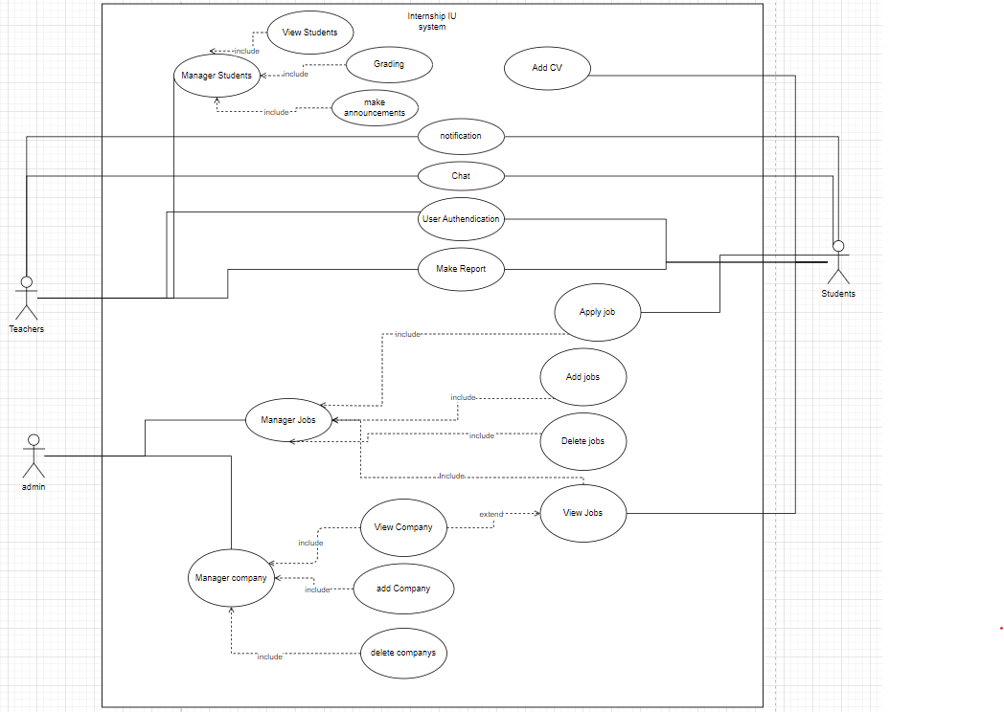

Figure : use case diagram

The website will have list of functions:

* Manager Students: This is function of Teacher. Manager Students will include:
  + View Students: web display list student
  + Grading: Show form to grading for student
  + Make announcements: form to send announcements for students (it also sends announcements via email)
* Add CV: Make upload file for students to submit their CV.
* Chat: a chat box for students and teacher can communicate.
* User Authentication: Use account provided by school to access.
* Make Report: provide list of templates for students and teacher.
* Manager jobs:
  + Apply job: form apply job and sent mail to recruiter of company.
  + View job: display list card job for student.
  + Add job: add new job follow form to add database.
  + Delete job: remove job out of database.
* Manager company:
  + View Company: a page displays company information.
  + Add company: add company to database.
  + Delete company: remove company out of database.

# CHAPTER 3

# GOAL ATTAINMENT



## Current work.

A page on users is the authentication page here is a page for students or Teachers will use their account provided by the school to access Internship IU.

Figure : login page

### Students

This information of student page will display all critical information about students and also show the processed internship of students.

Figure : User information page

Next is the home page of the student role. On this page display list of jobs for students applying. Jobs will display base on Students area of expertise.

Figure : Home page of students

This modal display details of jobs for students can read and apply for jobs. Modal job will display name, company name, requirement, description, …

Figure : Modal of job view

When user click title of job in modal job it will redirect to company page.

Figure : Jobs page

Apply form page will display job and student information will send to the recruiter by mail.

Figure : Apply form.

The jobs applied for will display on the applied page. On this page, students can register their job if they can find a job outside or student receive a job from the Company they apply.

Figure : Display jobs applied page.

Figure : Register job form

Figure : Register instructor form

After finishing the internship, they can find a report form on this website and submit it through the Internship IU website.

Figure : Report page

### Teacher

Teachers will see a list of students and their managers. On this page, Teach can quickly observe the process of student support immediately.

Figure : Home page of Teacher

When clicking on the student card. The web will redirect to the Student page to view detail. On this student page, the teacher can grade and make an announcement if students have problems with their CVs or report.

Figure : View Student

Annoncement from :

Figure : Announcement form

Grade form

Figure : Grading form

This grade page will display a list of students with their grades, easy for the teacher can observe and modify if the Teacher has a problem. It also can export for teach can make a report for school later.

Figure : Grade view page

Teachers can find some report forms on this page and submit them to the school by mail.

Figure : Report page

## Compare with the initial requirements.

About the

# CHAPTER 4

# FUTURE WORK

# REFERENCES

1. [What is React (w3schools.com)](https://www.w3schools.com/whatis/whatis_react.asp)

My source code

https://github.com/hainamtr317/InternshipIU.git

# APPENDIX